## 制作本地仓库

1. 安装 Apache HTTP 服务器

yum install httpd

systemctl start httpd.service

systemctl enable httpd.service

1. 安装本地源制作相关工具

yum –y install yum-utils createrepo

1. 下载安装资源

mkdir /var/www/html/ambari

mkdir /var/www/html/HDP

mkdir /var/www/html/HDP-UTILS

cd /var/www/html/ambari

wget http://public-repo-1.hortonworks.com/HDP/centos7/2.x/updates/2.6.0.3/HDP-2.6.0.3-centos7-rpm.tar.gz

wget http://public-repo-1.hortonworks.com/ambari/centos7/2.x/updates/2.5.1.0/ambari-2.5.1.0-centos7.tar.gz

wget http://public-repo-1.hortonworks.com/HDP-UTILS-1.1.0.21/repos/centos7/HDP-UTILS-1.1.0.21-centos7.tar.gz

tar –zxvf HDP-2.6.0.3-centos7-rpm.tar.gz –C /var/www/html/HDP

tar –zxvf ambari-2.5.1.0-centos7.tar.gz –C /var/www/html/ambari

tar –zxvf HDP-UTILS-1.1.0.21-centos7.tar.gz –C /var/www/html/HDP-UTILS

# 安装开始：

## 1.关闭防火墙和selinux

systemctl stop firewalld.service #停止firewall

systemctl disable firewalld.service #禁止firewall开机启动

firewall-cmd --state #查看默认防火墙状态（关闭后显示notrunning，开启后显示running）

vi /etc/selinux/config

SELINUX=disabled

## 2.修改主机名

vi /etc/hosts

192.168.189.142 master01 master01.hadoop

192.168.189.143 slave01 slave01.hadoop

192.168.189.144 slave02 slave02.hadoop

vi /etc/sysconfig/network

NETWORKING=yes

HOSTNAME=master01.hadoop

vi /etc/sysconfig/network

NETWORKING=yes

HOSTNAME=slave01.hadoop

vi /etc/sysconfig/network

NETWORKING=yes

HOSTNAME=slave02.hadoop

## 3.安装ssh证书

ssh-keygen -t rsa【生成秘钥】

ssh-copy-id -i .ssh/id_rsa.pub master01【拷贝秘钥】

ssh-copy-id -i .ssh/id_rsa.pub slave01【拷贝秘钥】

ssh-copy-id -i .ssh/id_rsa.pub slave02【拷贝秘钥】

## 开启NTP服务

所有集群上节点都需要操作

yum install ntp

systemctl is-enabled ntpd

systemctl enable ntpd

systemctl start ntpd

ntpdate 192.168.11.124

## 安装JDK1.8

wget <http://public-repo-1.hortonworks.com/ARTIFACTS/jdk-8u112-linux-x64.tar.gz>

所有节点：

tar –zxvf jdk-8u112-linux-x64.tar.gz –C /usr/local/java

vi /etc/profile

export JAVA_HOME=/usr/local/java/jdk1.8.0_112

export CLASSPATH=.:$JAVA_HOME/lib/dt.jar:$JAVA_HOME/lib/tools.jar

export PATH=$PATH:$HOME/bin:$JAVA_HOME/bin

source /etc/profile

## 主节点安装mysql

1. 下载mysql的repo源（CentOS 7.2的yum源中默认没有mysql,要先下载mysql的repo源）

wget <http://repo.mysql.com/mysql57-community-release-el7-8.noarch.rpm>

1. 安装mysql57-community-release-el7-8.noarch.rpm包

rpm -ivh mysql57-community-release-el7-8.noarch.rpm –nodeps

安装这个包后，会获得两个mysql的yum repo源：/etc/yum.repos.d/mysql-community.repo，/etc/yum.repos.d/mysql-community-source.repo

1. 安装Mysql

yum –y install mysql-server

1. 启动mysql服务

systemctl restart mysqld

service mysqld status

1. 重置root密码

MySQL为root用户生成的随机密码通过mysqld.log文件可以查找到：

grep 'temporary password' /var/log/mysqld.log

修改root用户密码：(MySQL的密码策略比较复杂，过于简单的密码会被拒绝)

mysql -u root –p

mysql> Enter password: （输入刚才查询到的随机密码）

mysql> SET PASSWORD FOR 'root'@'localhost'="Hadoop-123";

mysql> exit

注意：以上如果失败参考

<http://blog.csdn.net/lochy/article/details/51721319>

或：执行以下操作

关闭服务

systemctl stop mysqld.service

vi /etc/my.cnf

mysqld下面添加skip-grant-tables 保存退出启动服务

systemctl start mysqld.service

mysql -u root 不用密码直接回车

use mysql

update user set authentication_string=password('Hadoop-123') where User='root' and Host='localhost';

flush privileges;

exit;

vi /etc/my.cnf 把 skip-grant-tables 一句删除保存退出重启mysql服务

systemctl restart mysqld.service

再次登录即可

mysql -u root -pHadoop-123

如果进行操作出现下面的提示:

You must reset your password using ALTER USER statement before executing this statement.

就再设置一遍密码

set password = password('Hadoop-123');

1. 开放3306端口

允许使用用户名root密码Hadoop-123从任何主机连接到mysql服务器

mysql>GRANT ALL PRIVILEGES ON *.* TO 'root'@'%' IDENTIFIED BY 'Hadoop-123' WITH GRANT OPTION;

mysql>FLUSH PRIVILEGES;

mysql>exit;

1. 创建ambari数据库及用户，登录root用户执行下面语句：

create database ambari character set utf8 ;

GRANT ALL PRIVILEGES ON *.* TO 'ambari'@'%' IDENTIFIED BY 'Ambari-123';

FLUSH PRIVILEGES;

如果要安装Hive，再创建hive数据库和用户 再执行下面的语句：

create database hive character set utf8 ;

GRANT ALL PRIVILEGES ON *.* TO 'hive'@'%' IDENTIFIED BY 'Hive-123';

FLUSH PRIVILEGES;

如果要安装Oozie，再创建Oozie数据库和用户 再执行下面的语句：

create database oozie character set utf8 ;

GRANT ALL PRIVILEGES ON *.* TO 'oozie'@'%' IDENTIFIED BY 'Oozie-123';

FLUSH PRIVILEGES;

8.安装mysql jdbc 驱动

yum install mysql-connector-java

## 配置本地yum仓库

cat <<EOF >/etc/yum.repos.d/ambari.repo

[Updates-ambari-2.5.1.0]

name=ambari-2.5.1.0 - Updates

baseurl=http://10.8.1.140/ambari/ambari/centos7/

gpgcheck=1

gpgkey= http://10.8.1.140/ambari/ambari/centos7/RPM-GPG-KEY/RPM-GPG-KEY-Jenkins

enabled=1

priority=1

EOF

cat <<EOF >/etc/yum.repos.d/hdo.repo

[HDP-2.6.0.3]

name=HDP Version - HDP-2.6.0.3

baseurl=http://10.8.1.140/HDP/HDP/centos7/

gpgcheck=1

gpgkey= http://10.8.1.140/HDP/HDP/centos7/RPM-GPG-KEY/RPM-GPG-KEY-Jenkins

enabled=1

priority=1

EOF

cat <<EOF >/etc/yum.repos.d/hdp-util.repo

[HDP-UTILS-1.1.0.21]

name=HDP Utils Version - HDP-UTILS-1.1.0.21

baseurl= http://10.8.1.140/HDP-UTILS/

gpgcheck=1

gpgkey= http://10.8.1.140/HDP-UTILS/RPM-GPG-KEY/RPM-GPG-KEY-Jenkins

enabled=1

priority=1

EOF

yum clean all

yum list update

yum makecache

yum repolist

## 开始安装ambari-server

yum install ambari-server

## 安装完成后，开始进行配置

ambari-server setup

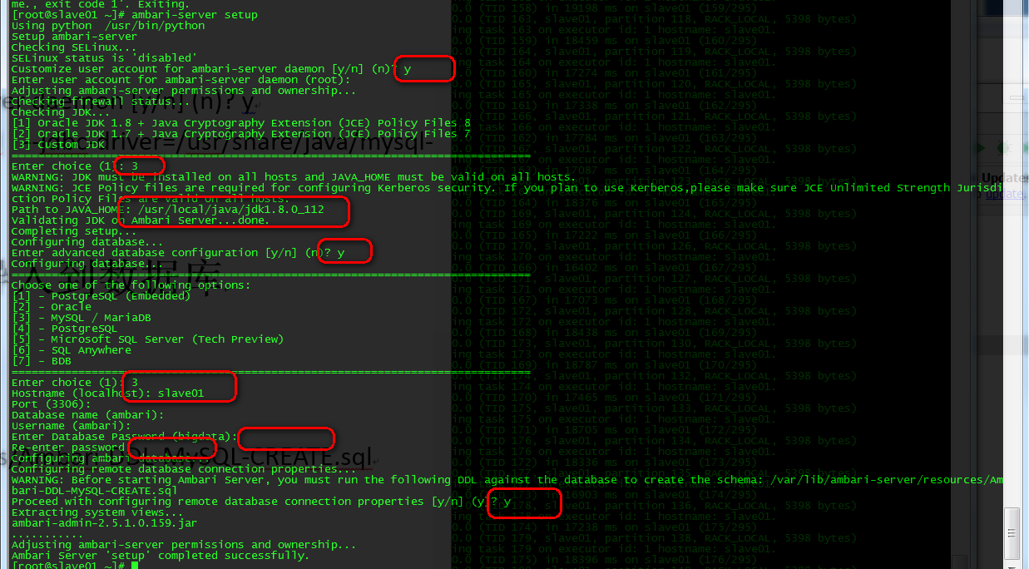

ambari-server setup --jdbc-db=mysql --jdbc-driver=/usr/share/java/mysql-connector-java.jar

## 将Ambari数据库脚本导入到数据库

mysql -u ambari -pAmbari-123

use ambari

source /var/lib/ambari-server/resources/Ambari-DDL-MySQL-CREATE.sql

## 启动Ambari

ambari-server start

成功启动后在浏览器输入Ambari地址：

http://192.168.189.145:8080/

出现登录界面，默认管理员账户登录， 账户：admin 密码：admin

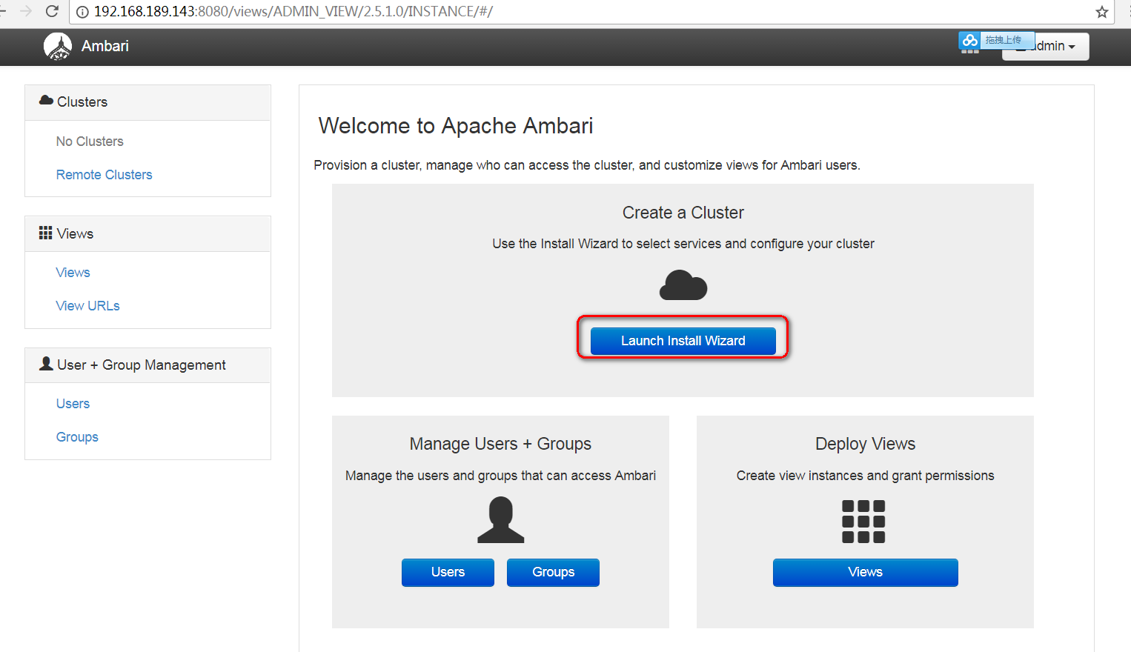

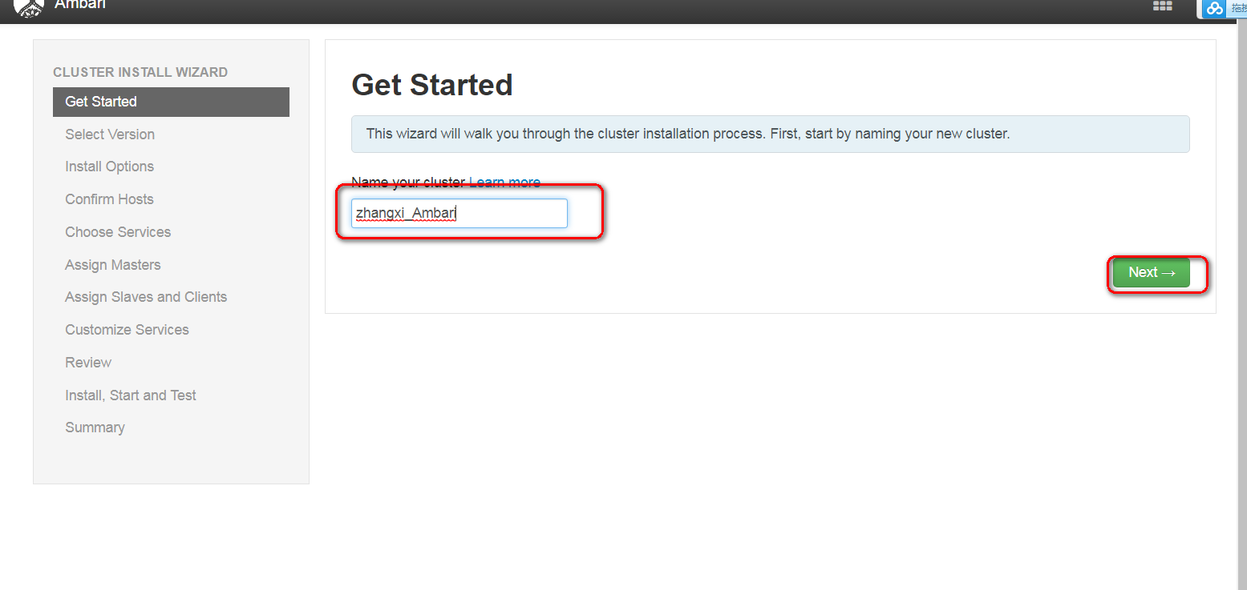

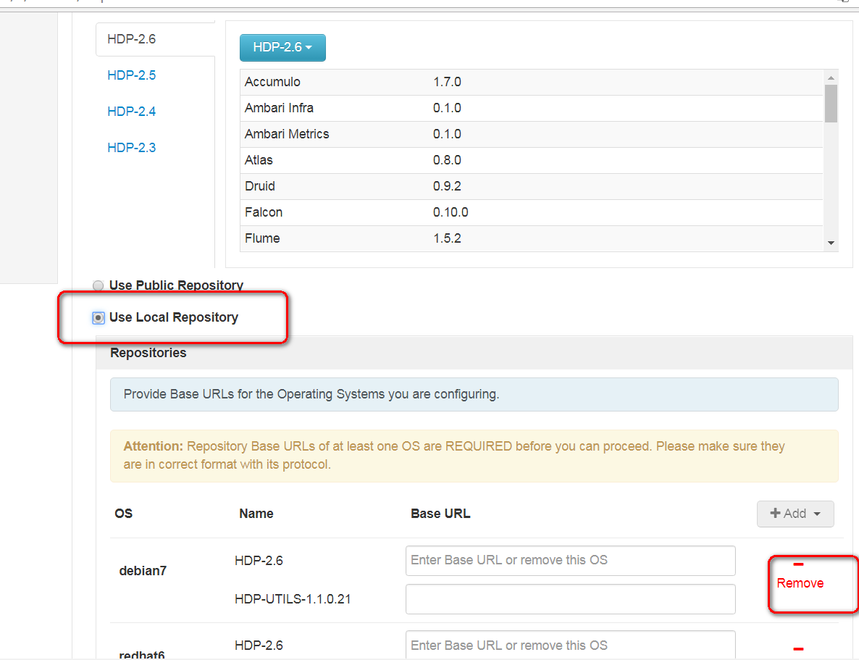

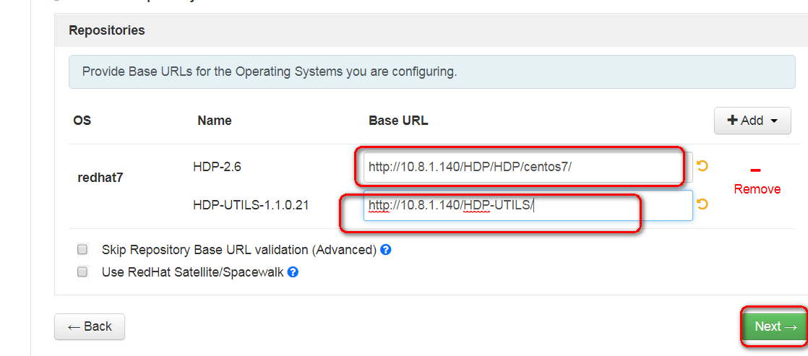

<http://10.8.1.140/HDP/HDP/centos7/>

http://10.8.1.140/HDP-UTILS/

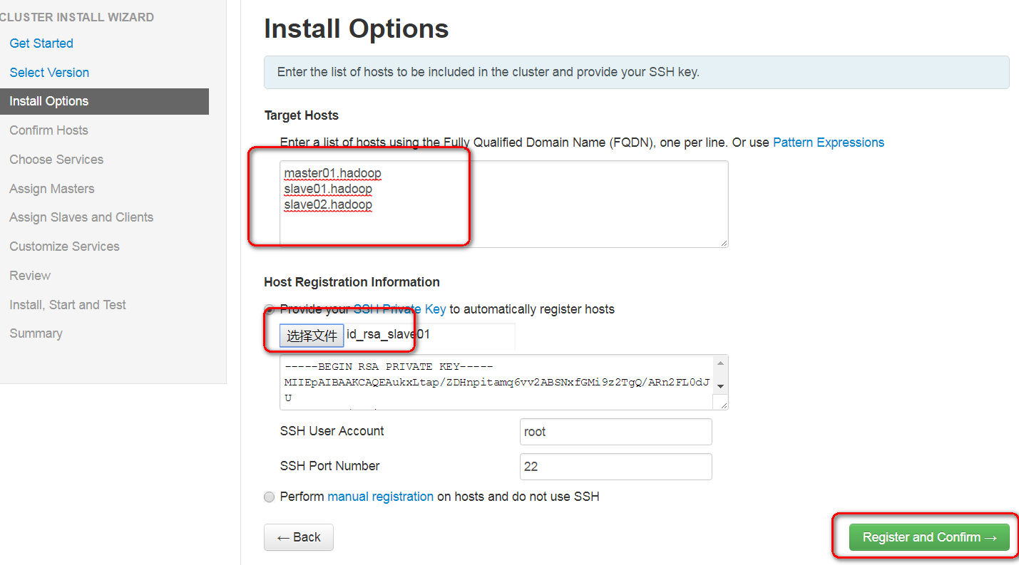

指主节点私钥

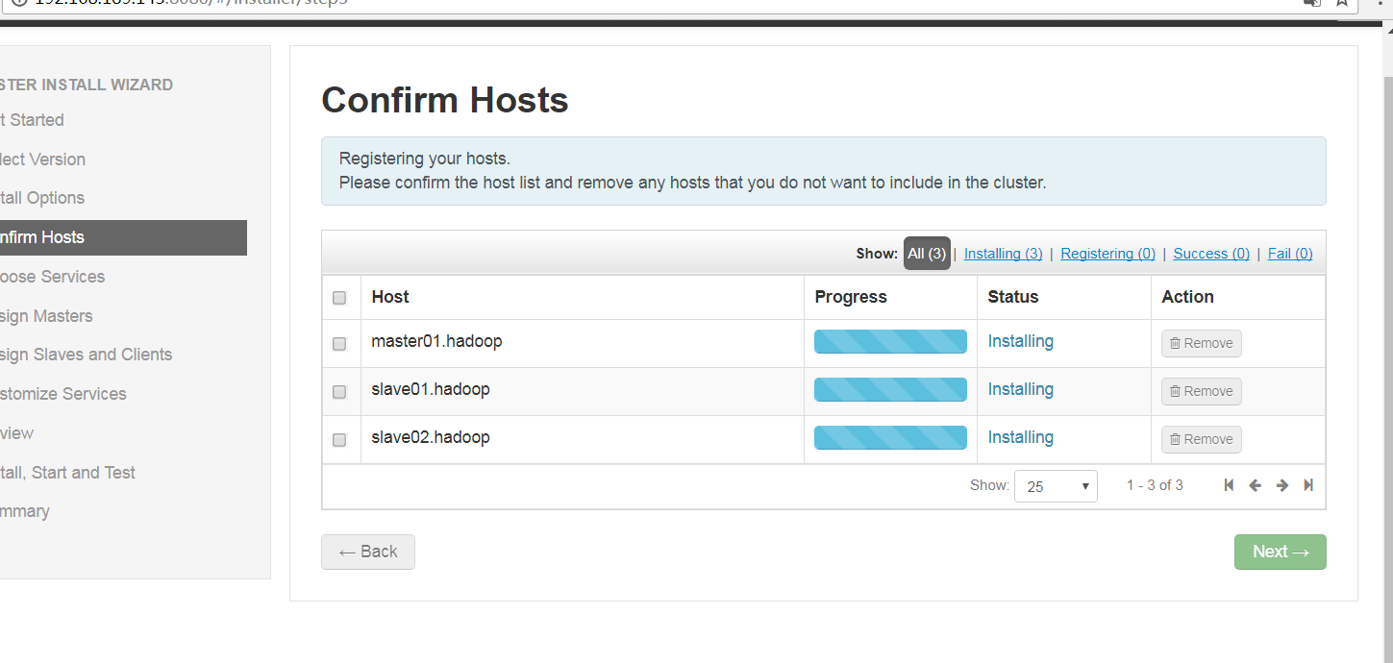

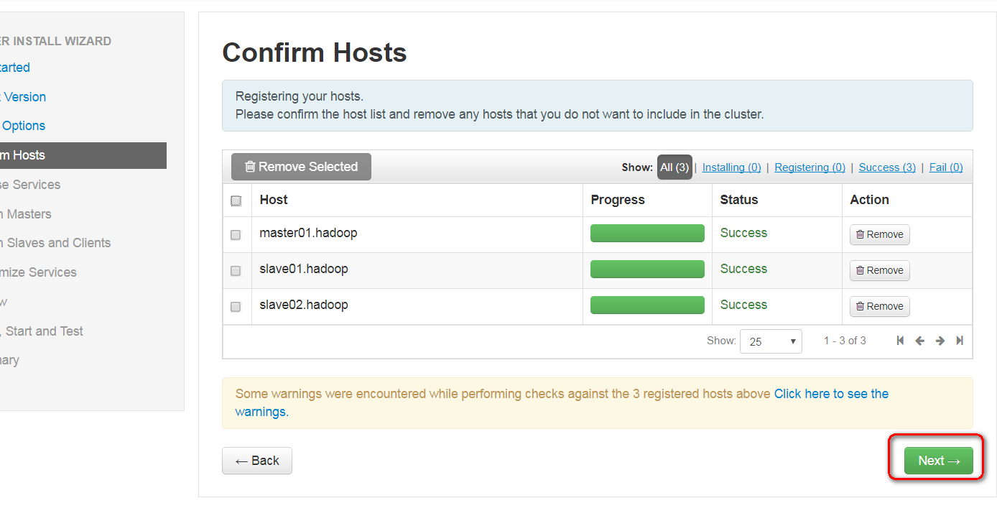

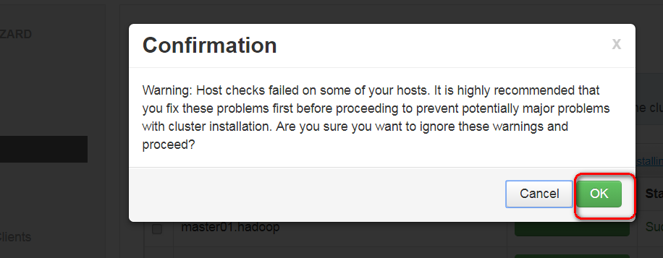

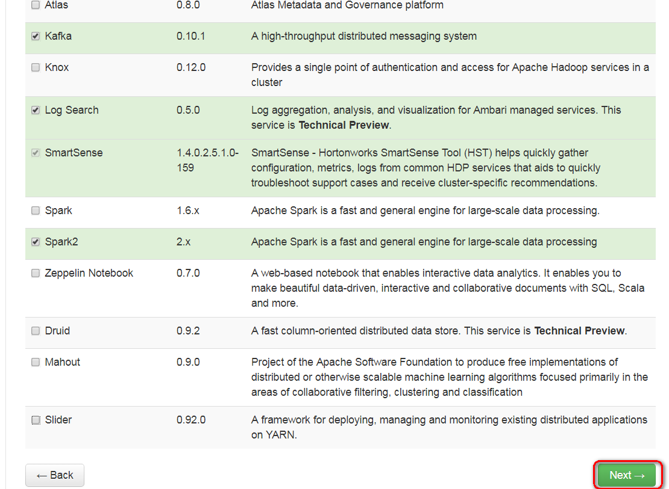

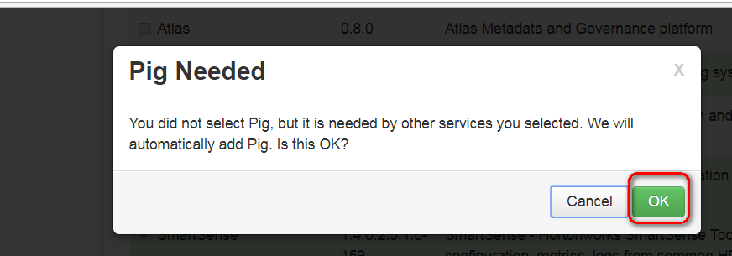

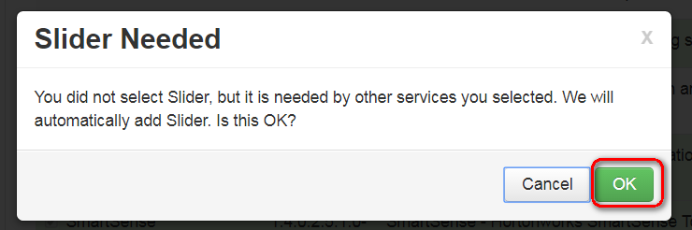

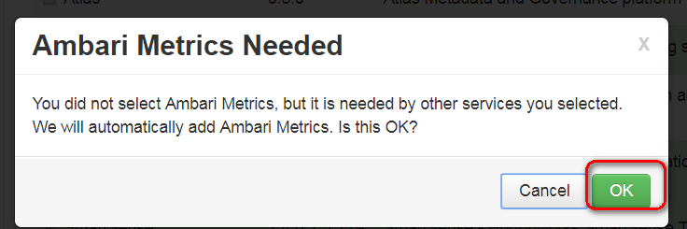

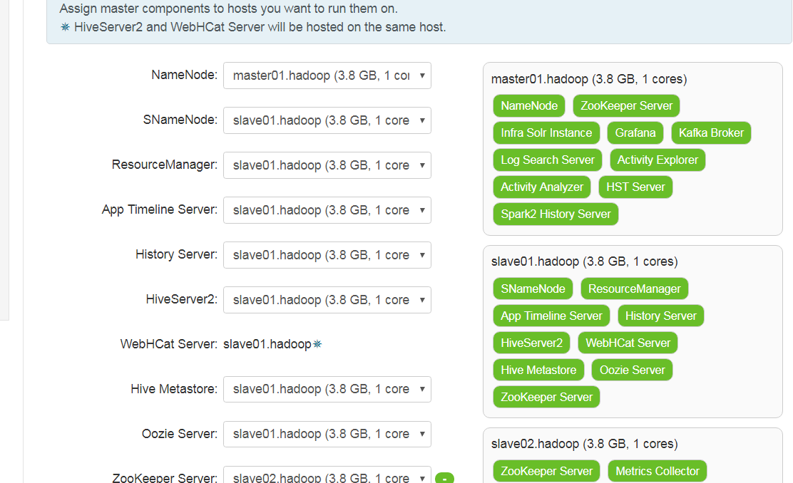

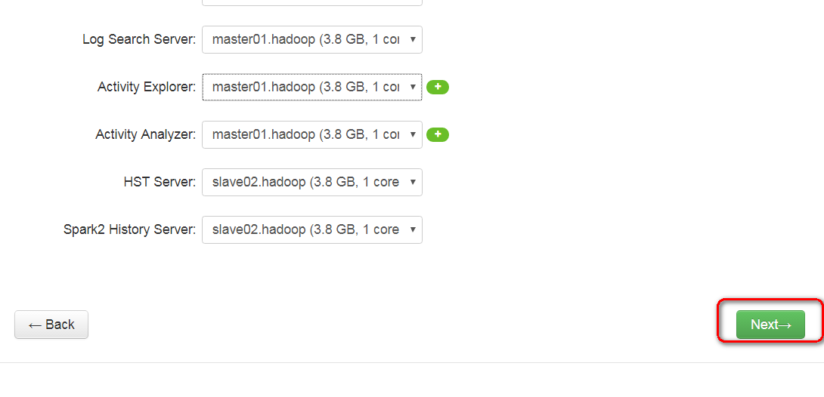 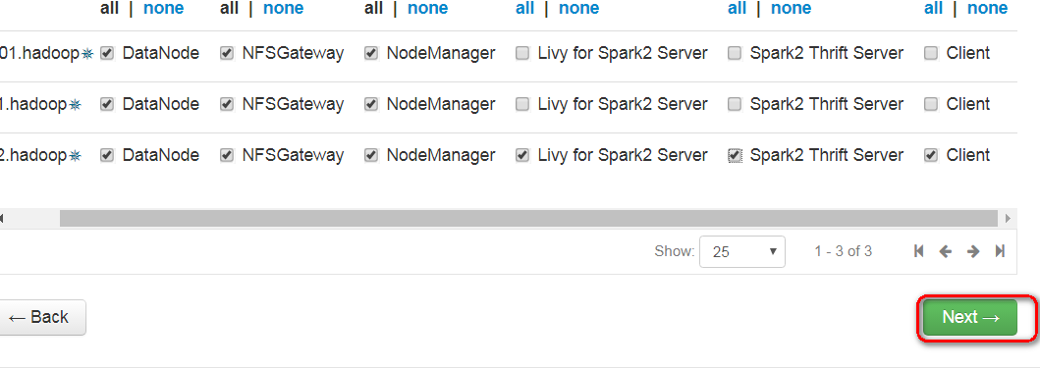

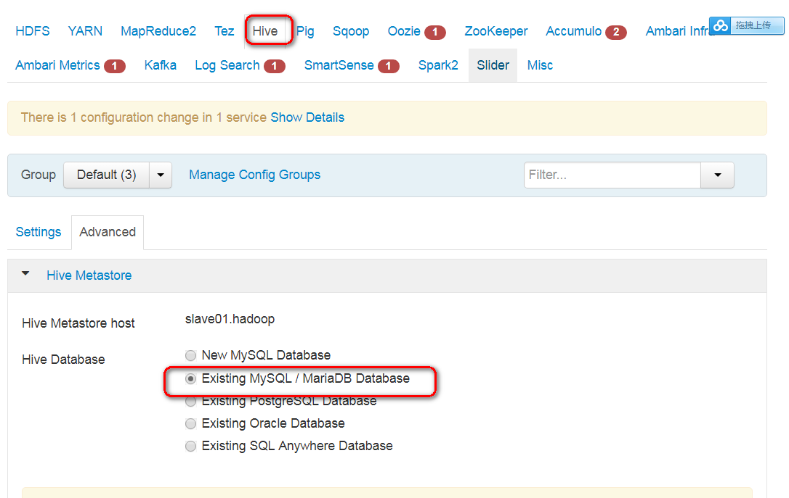

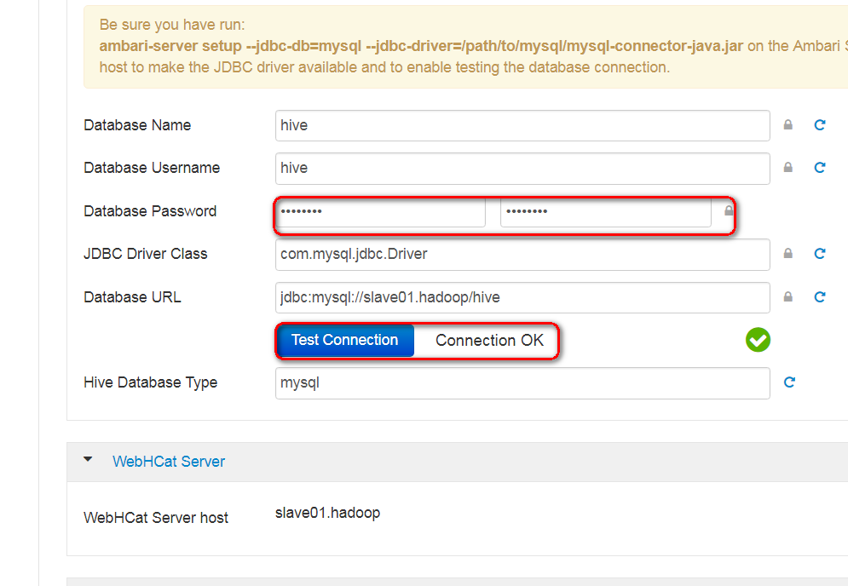

Hive-123

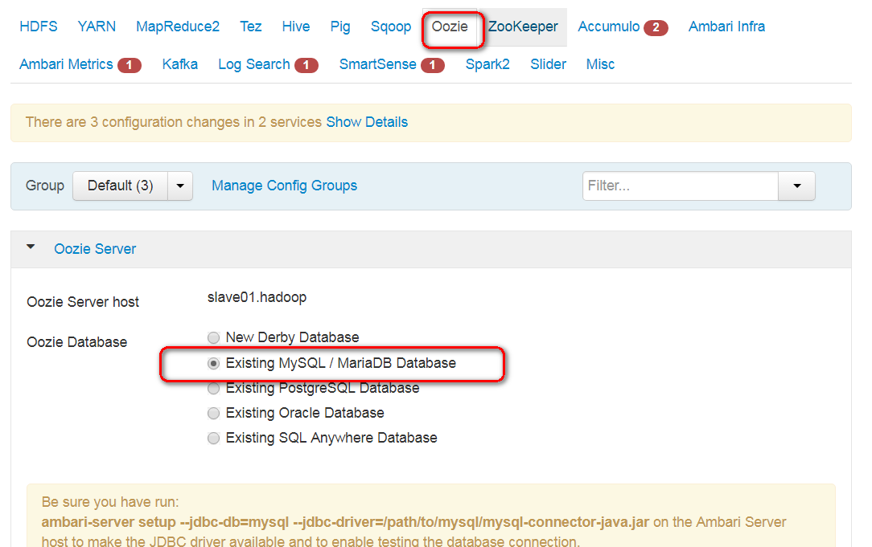

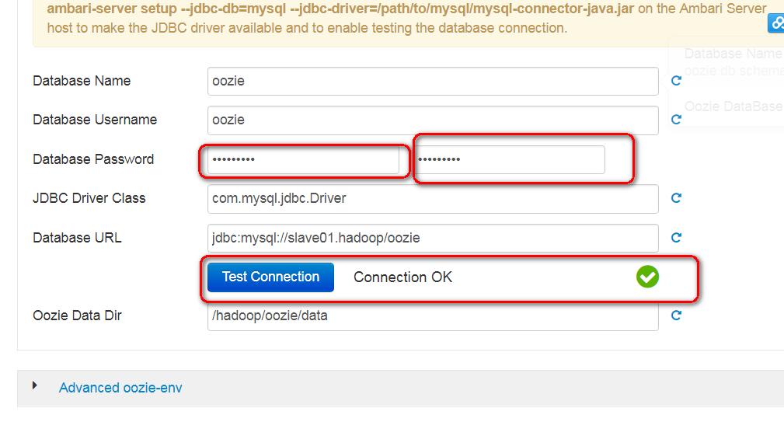

Oozie-123

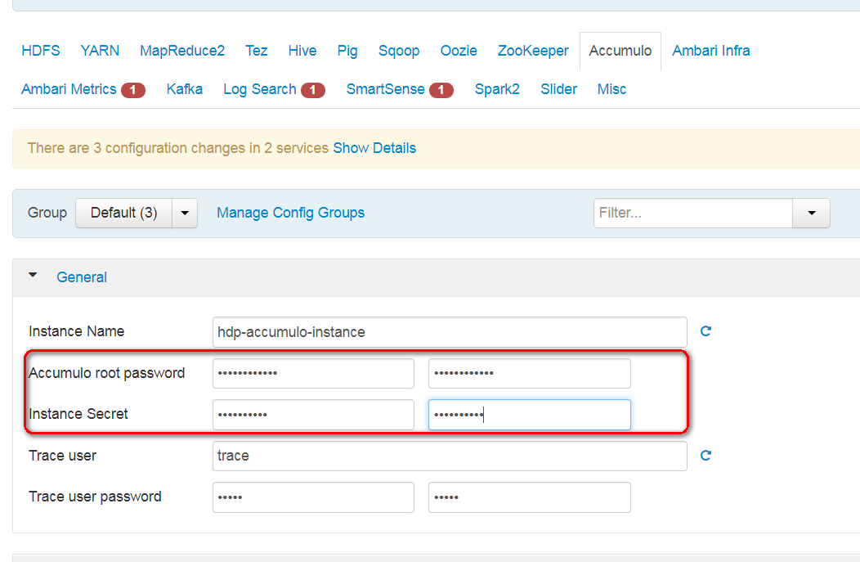

Accumulo-123

Secret-123

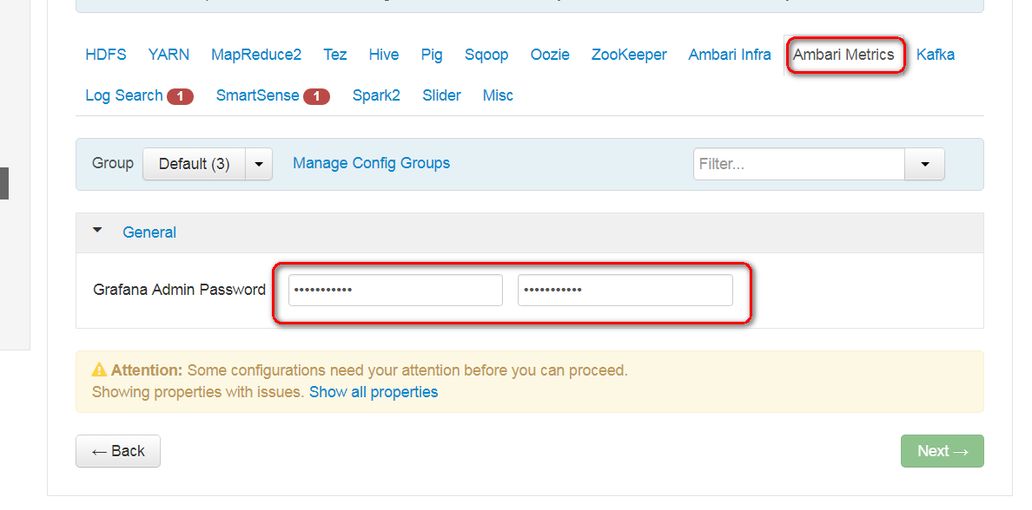

Grafana-123

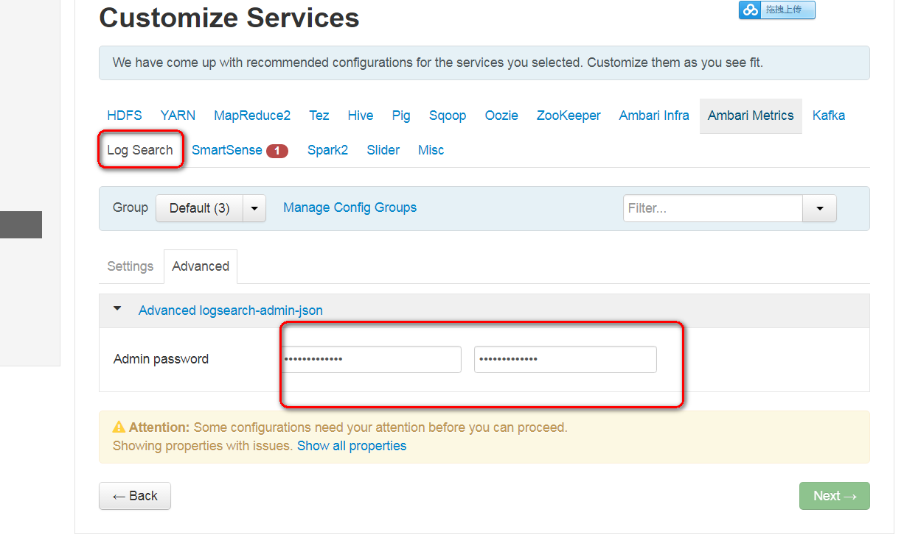

Logsearch-123

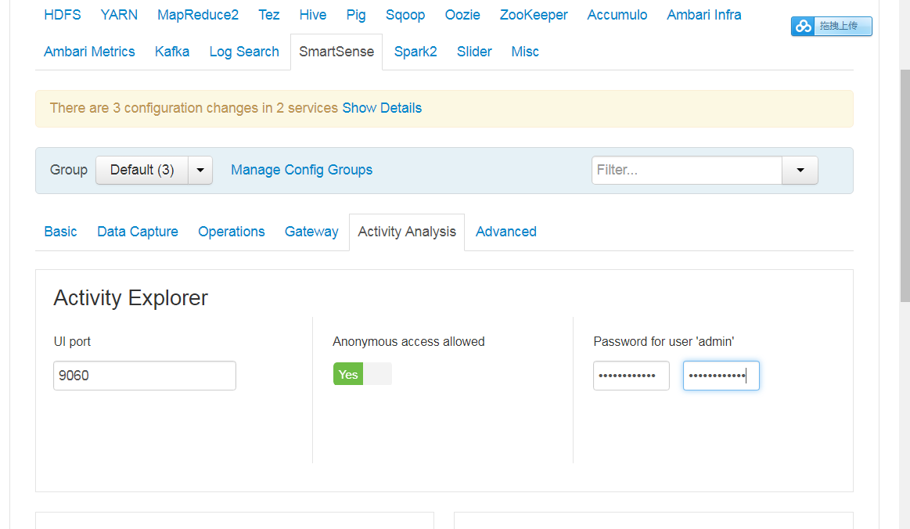**Explorer-123**

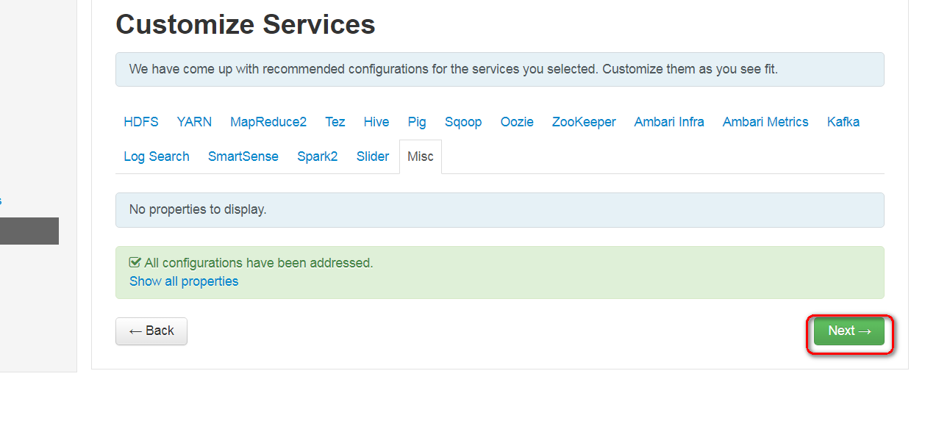

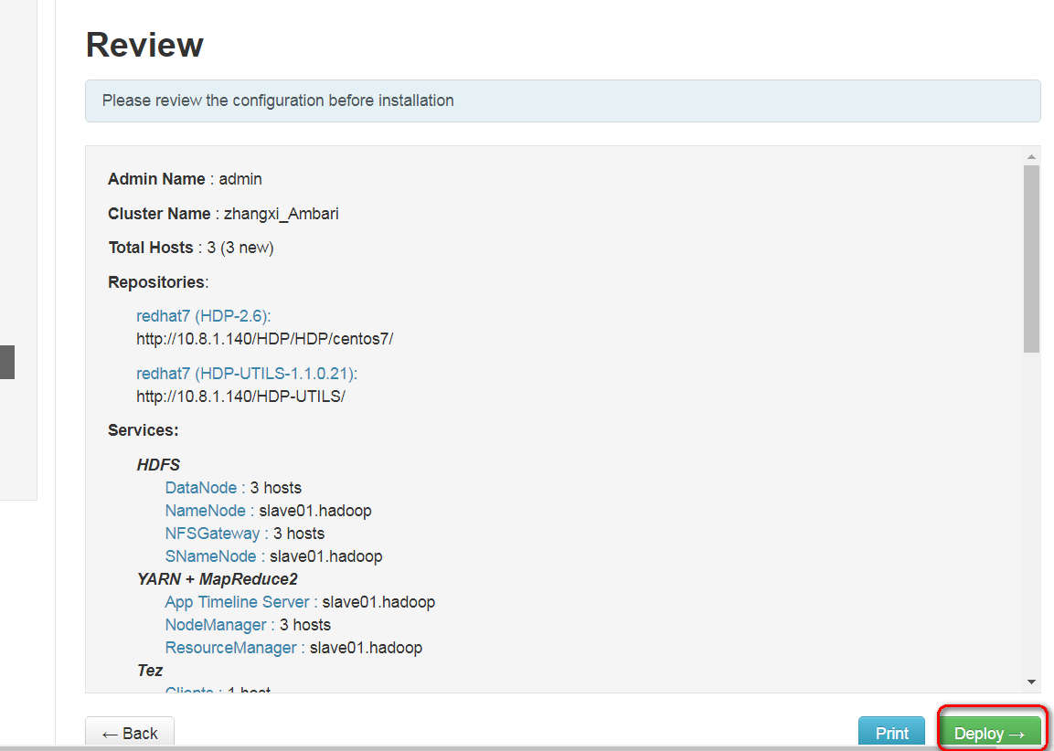

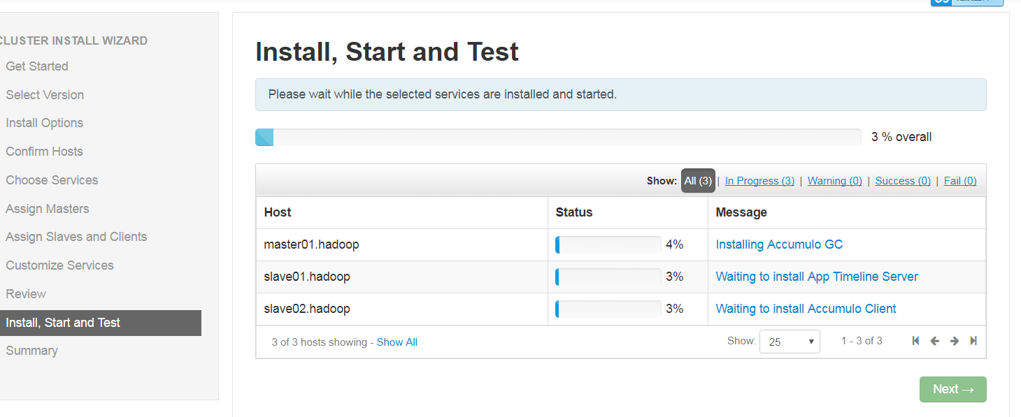

<http://192.168.189.143:8080/#/installer/step9>

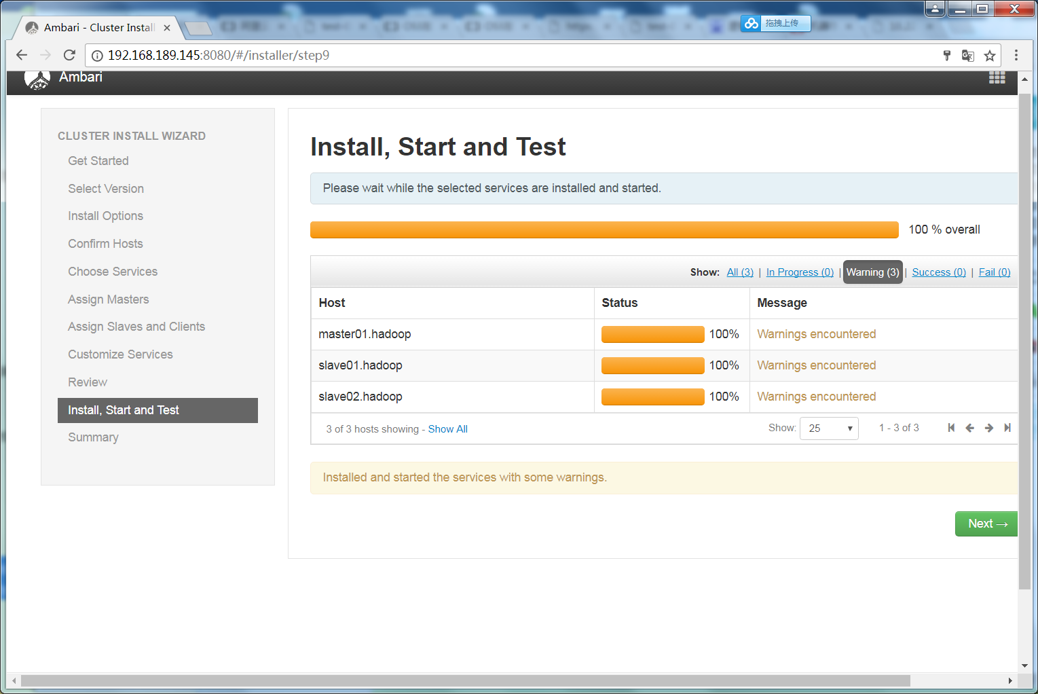

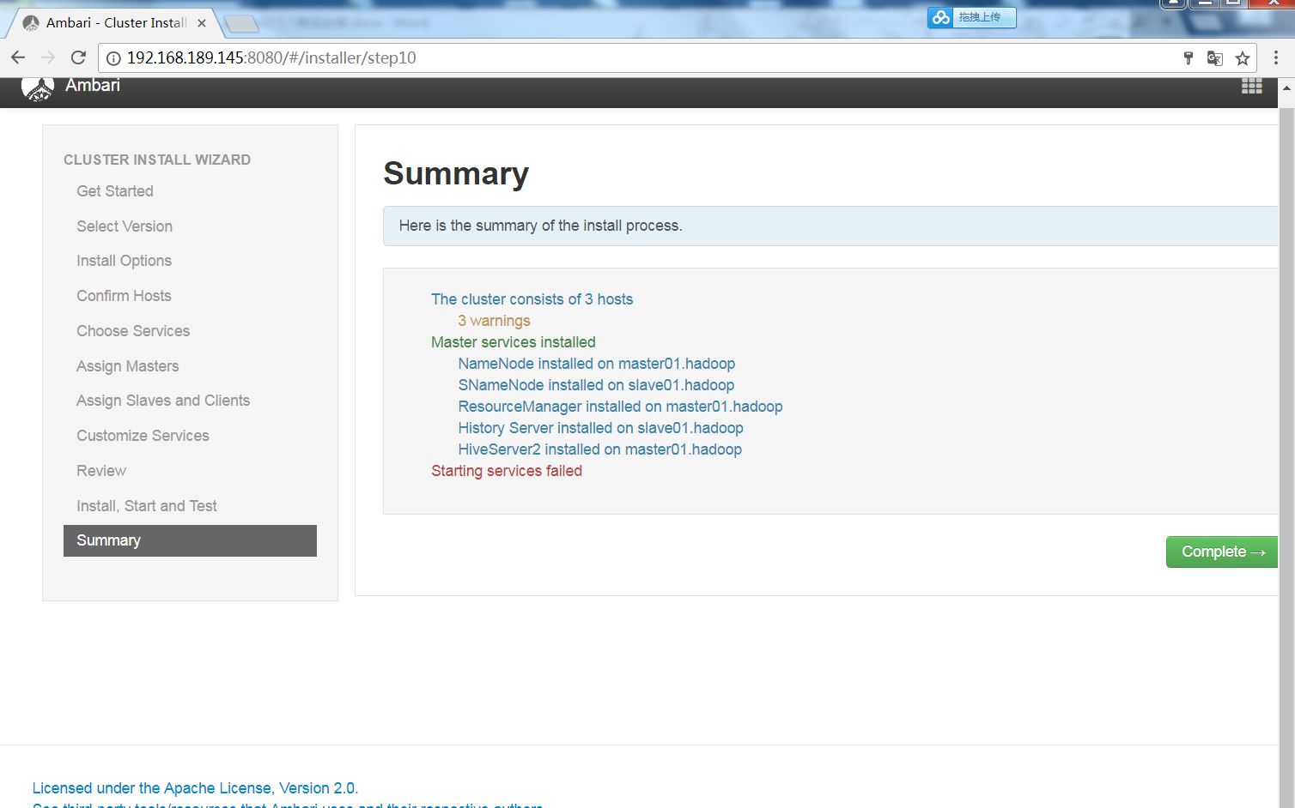

## 组件主目录

/usr/hdp